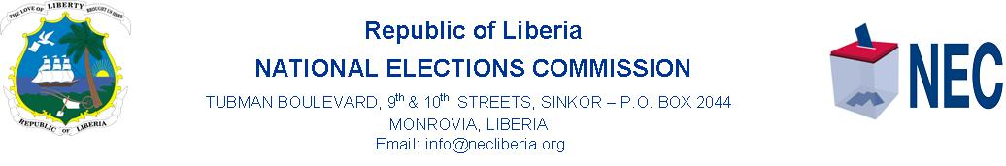
PRESS RELEASE
MONROVIA, 7 January 2022, the Gender Section of the National Elections Commission, (NEC), Friday commenced the first in a series of Internal Gender Trainings, focusing on understanding the specifics of Gender Concept and Mechanism in elections.
Nearly seventy-five NEC Staff, including Commissioners and Senior Technicians are expected to be trained as Core NEC Gender Staff. The trainings are under the theme, “Unpacking Gender in Elections”. The trainings are in partnership with the United Nations Women, or UN Women, and the government of Canada.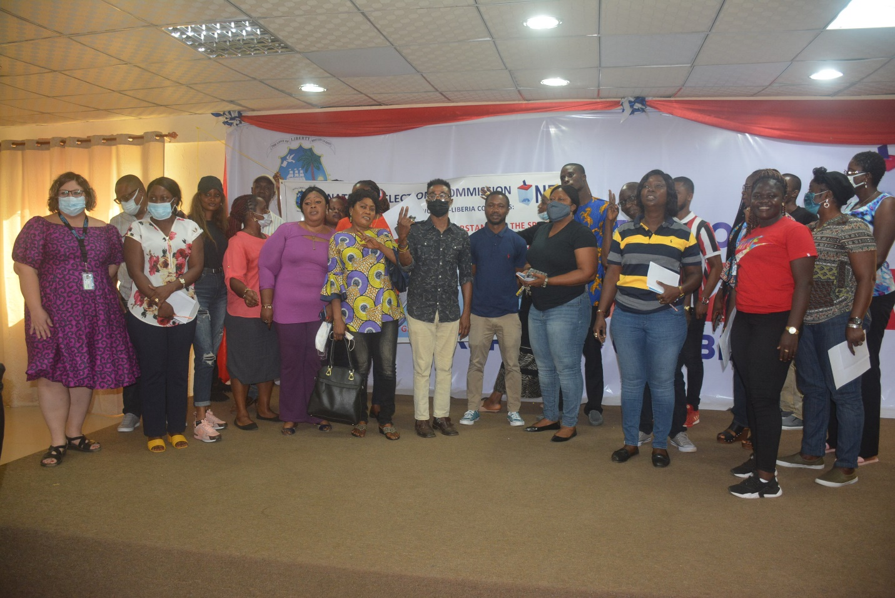 NEC-Core Gender Staff and UN-Women Expert on WPP, Lisa in a group photo in JMF Conf. Hall.

Giving the overview of the program at the Headquarters of the Commission, NEC Gender Director, Leisel Y. Talery said, the training forms part of the Section’s strategic plan to train employees, particularly on the current gender policy of the Commission.
For her part, the UN Women, Senior Expert on Women Political Participation, WPP, Lisa Kindervater spoke of the need to address the issue violence against women in elections. Madam Kindervater said violence is one of the barriers that affect the equal participation of women in elections.

